Hana Moskovitz
CS340

CS 340 README

About the Project/Project Title
Project title: Animal Records Manager

Motivation
The purpose of this project is to create a tool/application that allows someone to easily and repeatedly add, view, update, and delete animal records from the Austin Animal Center (AAC). I did this by connecting a Python program to a MongoDB database. This project uses PyMongo which is a Python driver for MongoDB, to connect a Python application to a MongoDB database. It allows Python to interact directly with MongoDB add, view, update, and delete records.

CRUD Operations
Create: create () allows you to add a new document into the animal collection. It will return True if the document is successfully added and False if it fails. If no data is provided, it will raise an exception.
Read: read () allows you to retrieve and view documents from the animal collection. If you provide search criteria, it returns matching documents. If you don’t then it returns all of the documents in the collection.
Update: update () allows you to specify and update documents in the animal collection. The method then returns the number of documents modified.
Delete: The delete () method removes documents from the animal collection based on specified search criteria. It then returns the number of documents deleted.

Getting Started
To get started you have to have and import aac_shelter_outcomes.csv file into MongoDB so that you have access to the animal’s collection. You then have to create a user account with appropriate permissions and update the python model to your own credentials (user name and password). Then you should be able to add, view, update, and delete animal records.

Installation
You need:
- Python 3
- MongoDB
- PyMongo

Usage

Code Example
# Complete this create method to implement the C in CRUD.
def create(self, data):
if data is not None:
try:
result = self.collection.insert_one(data)
if result.inserted_id:
return True
return False
except Exception as e:
print(f"Creat Error: {e}")
return False
else:
raise Exception("Nothing to save")

# Complete this read method to implement the R in CRUD.
def read(self, searchData=None):
try:
# If search information is provided then filter otherwise return all
if searchData:
cursor = self.collection.find(searchData, {"_id": False})
else:
cursor = self.collection.find({}, {"_id": False})

return list(cursor)

except Exception as e:
print(f"Read Error: {e}")
# Return an empty list if fail
return []

# Complete this update method to implement the U in CRUD.
def update(self, searchData, updateData, many=False):
if searchData is not None and updateData is not None:
try:
if many:
result = self.collection.update_many(searchData, updateData)
else:
result = self.collection.update_one(searchData, updateData)

return result.modified_count

except Exception as e:
print(f"Update Error: {e}")
return 0
else:
raise Exception("Nothing to update")

# Complete this delete method to implement the D in CRUD.
def delete(self, searchData, many=True):
if searchData is not None:
try:
if many:
result = self.collection.delete_many(searchData)
else:
result = self.collection.delete_one(searchData)

return result.deleted_count

except Exception as e:
print(f"Delete Error: {e}")
return 0
else:
raise Exception("Nothing to delete")

Tests
#imports CRUD module
from CRUD_Python_Module import AnimalShelter

#Instantiates an instance of the class
shelter = AnimalShelter()

#Uses create function create a new record in the aac database
test_animal = {
"age_upon_outcome": "1 year",
"animal_id": "T000",
"animal_type": "Cat",
"breed": "Black Cat",
"color": "Black",
"name": "Sunny",
"outcome_type": "Adoption"
}
is_created = shelter.create(test_animal)
print(f"Insert Successful: {is_created}")

#Uses the read function to return records from the aac database
search_query = {"name": "Sunny"}
results = shelter.read(search_query)
print(f"Result details: {results}")

#Uses the update function to update records in the aac database
update_data = {"$set": {"name": "Sunny Cat"}}
updated_count = shelter.update({"animal_id": "T000"}, update_data)
print(f"Update Successful: {updated_count}")

# Uses the delete function to delete records from the aac database
deleted_count = shelter.delete({"animal_id": "T000"})
print(f"Delete Successful: {deleted_count}")

Screenshots
MongoDB import execution:
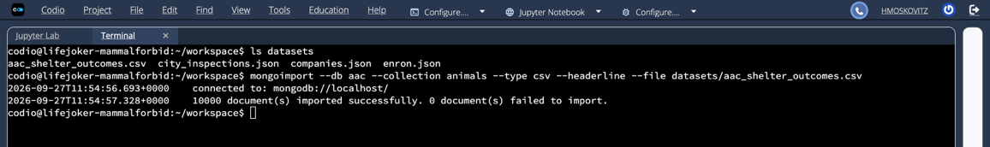
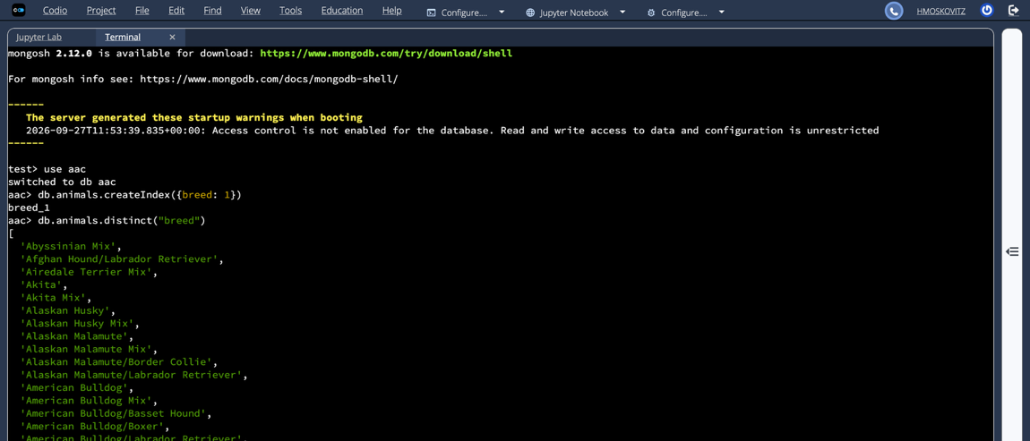
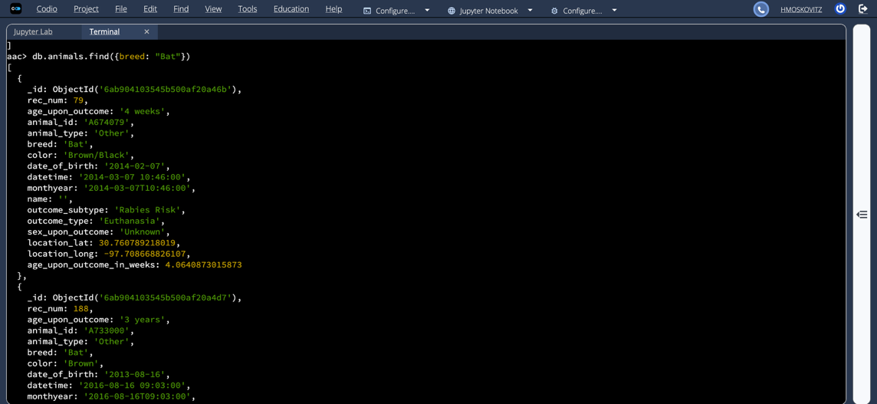
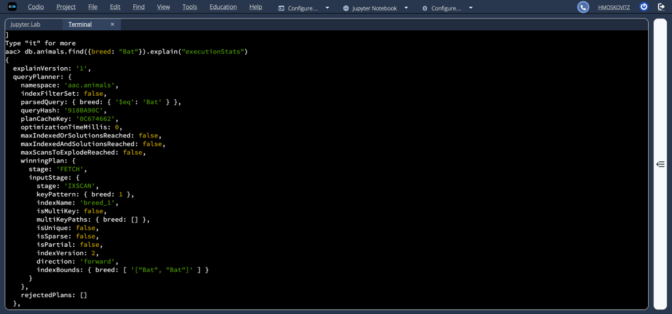
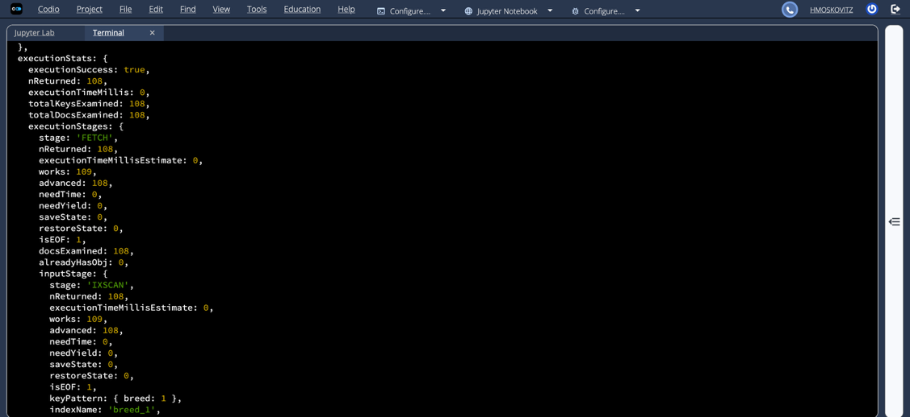
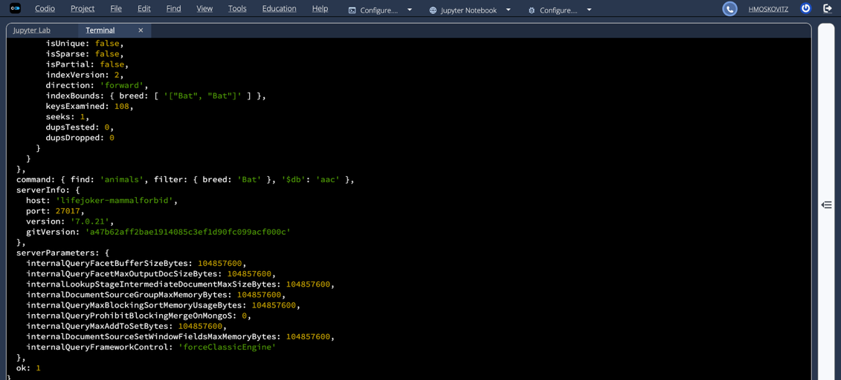
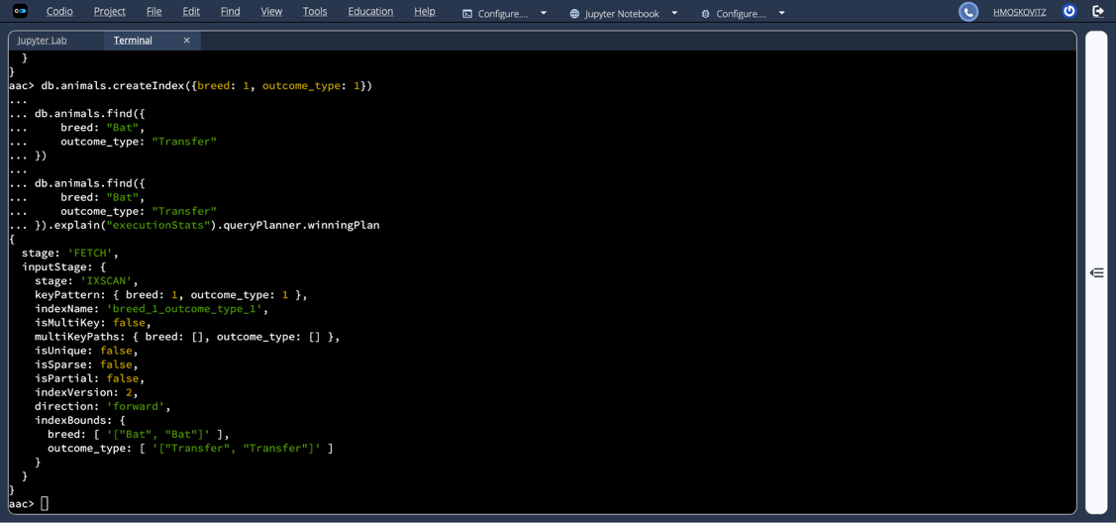
User authentication execution:
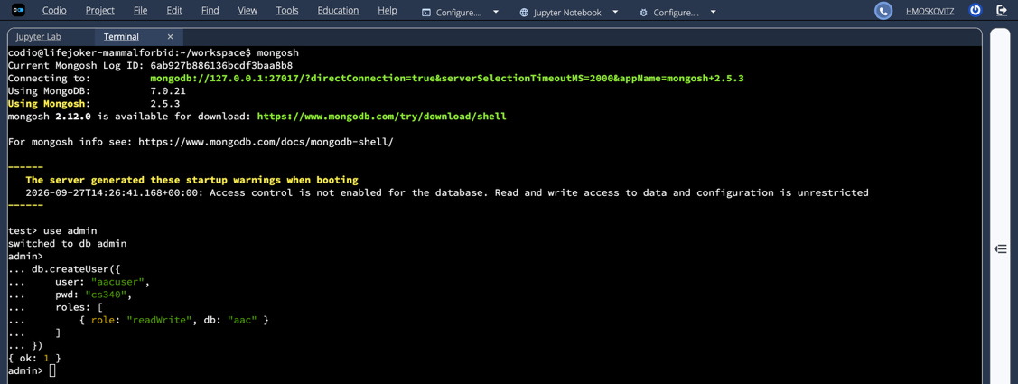
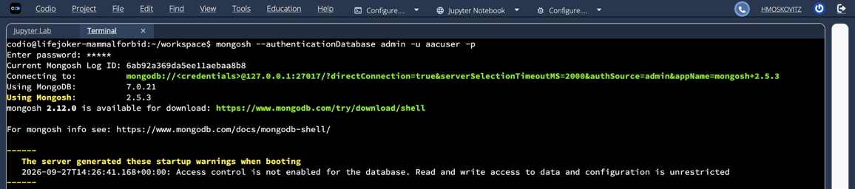
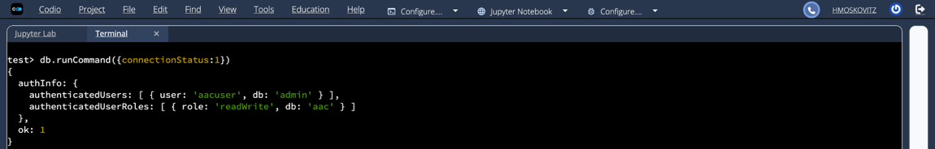

CRUD functionality test execution:
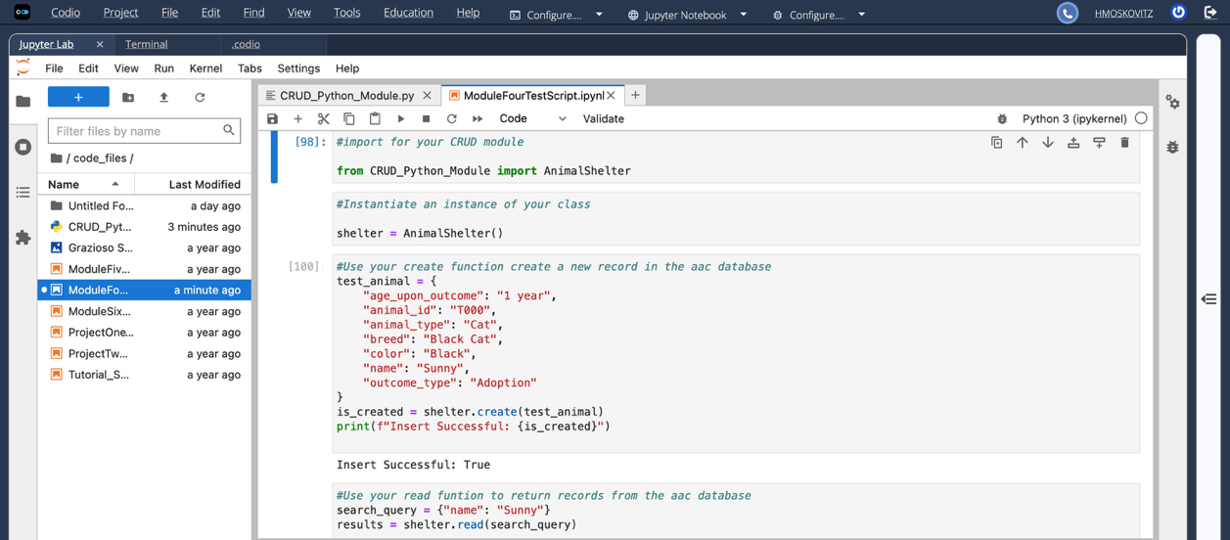

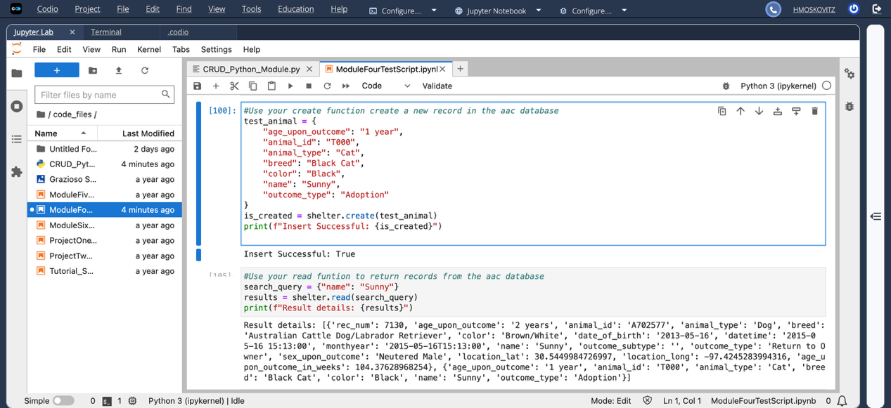
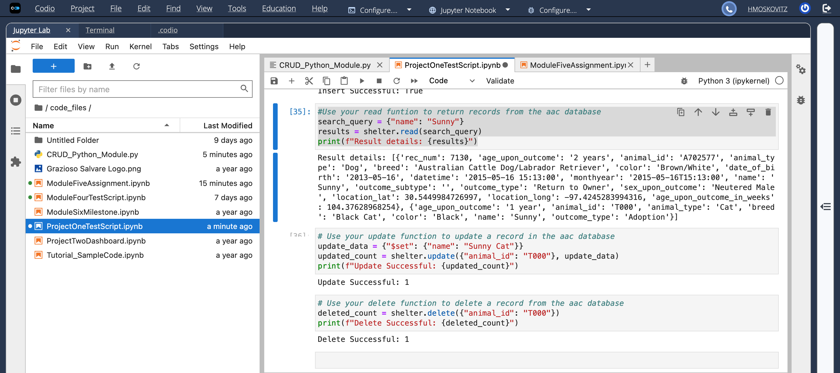

Dashboard Functionality

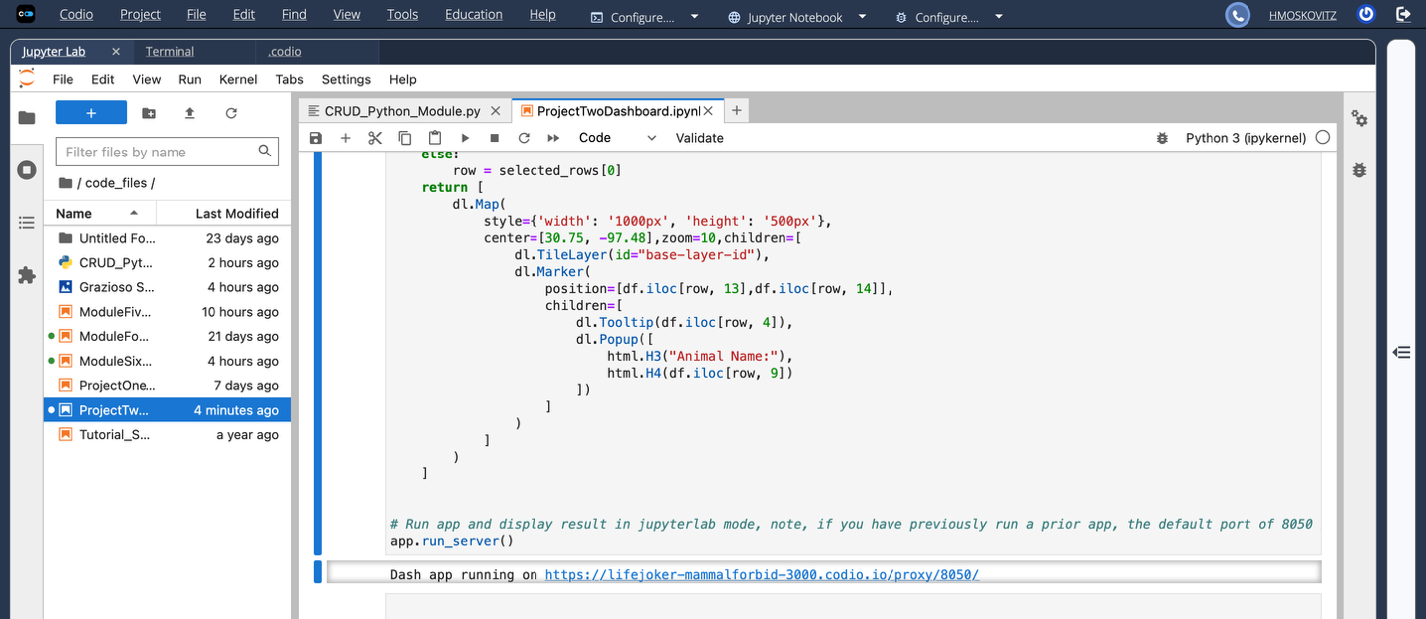
Water
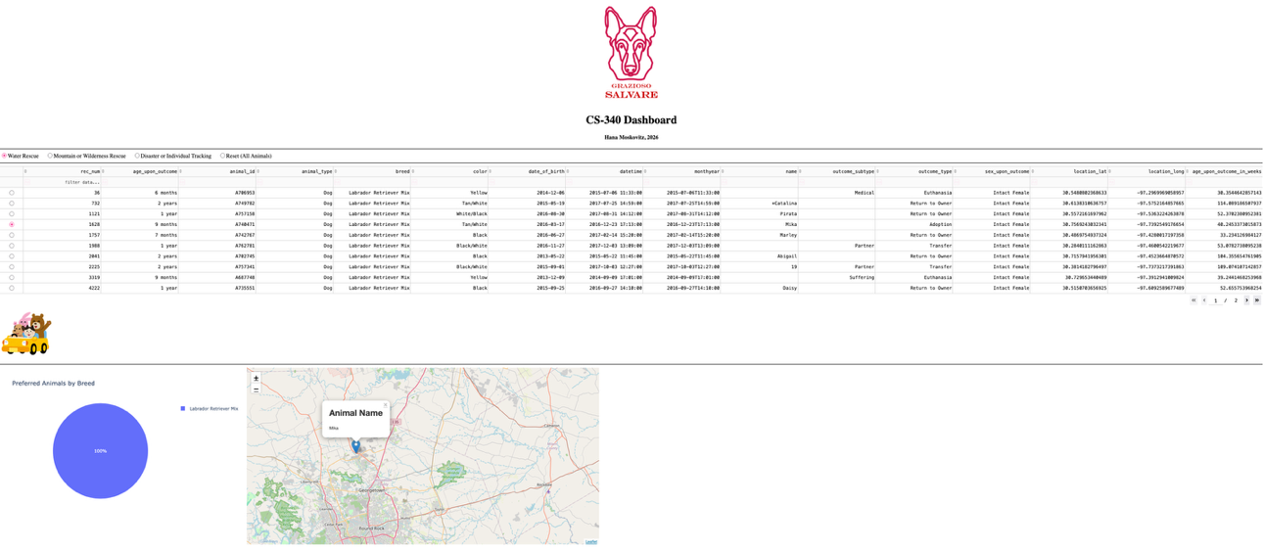
Mountain
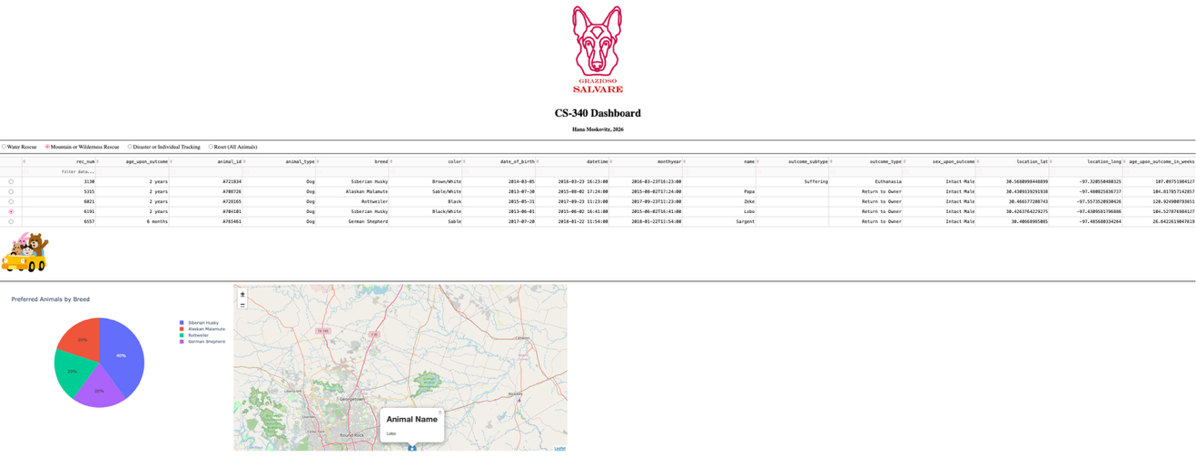
Disaster
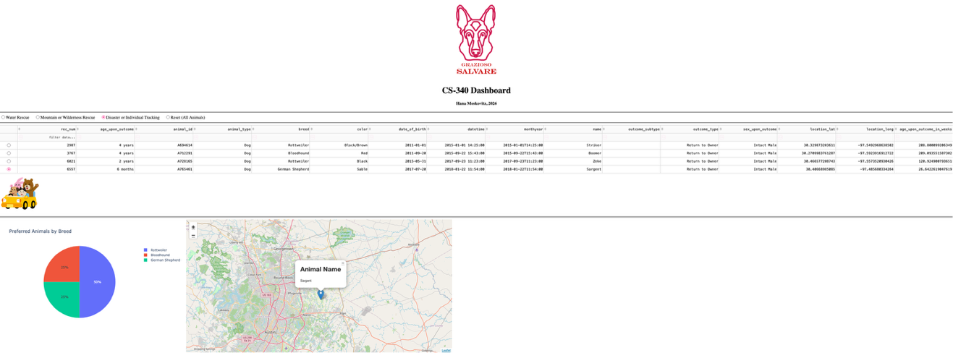
Reset
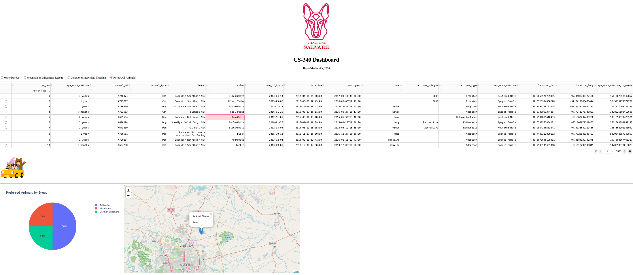

Contact
Your name: Hana Moskovitz

